**Probability:**

Probability means possibility. It is a branch of mathematics that deals with the occurrence of a random event. The value is expressed from zero to one. Probability has been introduced in Maths to predict how likely events are to happen.

* **Mutual Exclusive Events:**
* **Non Mutually Exclusive Events:**
* **Multiplication Events:**

**Mutual Exclusive Events:**

Two events are mutually exclusive if they can not occur at the same time. Example: Tossing a coin, Rolling a dice, winning and losing.

**Non Mutually Exclusive Events:**

Two events that occur at the same time.  
Example:   
1) Picking marble from a bag of marbles where it contains Red, Green, and half Red and half Green.

2) Picking random cards from a deck of cards two events of “Heart” and “King” can be selected.

**Multiplication Events:**

1. Dependents Events: Two events are dependent if they affect one another.

**Permutation:**

A permutation is an arrangement of objects in a definite order. The members or elements of sets are arranged here in a sequence or linear order.

Example the permutation of set A={1,6} is 2, such as {1,6}, {6,1}. As you can see, there are no other ways to arrange the elements of set A.

Example 2:- the permutation of set B={1,4,5} is 6, such as

{1,4,5}{1,5,4}

{4,5,1}{4,1,5}

{5,1,4}{5,4,1} .

As you can see, there are no other ways to arrange the elements of set B.

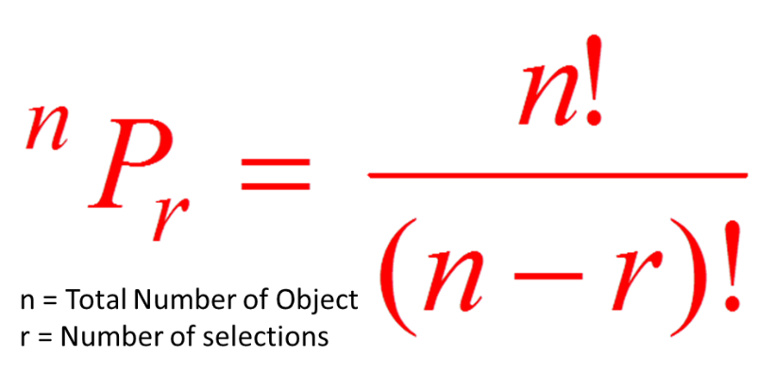

**Combination:**

A combination is a mathematical technique that determines the number of possible arrangements in a collection of items where the order of the selection does not matter with only unique combination where items are not repeating.

Example the Combination of set A={1,6} is 1, such as {1,6}. As you can see, there are no other ways to arrange the elements of set A with a unique combination where items are not repeating..

Example 2:- the permutation of set B={1,4,5} is 3, such as {1,4,5}, {4,5,1}, {5,1,4}. As you can see, there are no other ways to arrange the elements of set B with unique combination where items are not repeating..

